

Jarvis Consulting

Stock Trading Application
System Requirements Document (SRD)

Prepared by: | Dhwani Agrawal
Prepared for: | Solution Design Team at Jarvis
Date Submitted: | 4th March, 2026
Document Number: | 2026-03/01/SRD
Version: | 1.0
Last Updated: | 3rd March, 2026

Table of Contents

1. Introduction 4
Background 4
Project Stakeholders 4
Project Scope 4
Responsibilities 5
2. System Overview 5
3. Functional Requirement 5
User Authentication and Authorization 5
Account Linking and Management 5
Trade Execution 6
Order Management 6
Reporting and Statements 6
4. Non - Functional Requirement 6
Security 6
Performance 6
Availability 7
Scalability 7
Usability 7
5. Use Cases 8
6. Data Requirements / Modelling 9
7. Dependencies 10
8. Assumptions and Constraints 10

Revisions

Name | Date | Reason For Changes | Version
Dhwani Agrawal | March 3, 2026 | Initial draft for internal discussion | v0.1

Introduction

Background

Our bank currently does not provide an in-house stock trading platform. Customers rely on third-party trading applications to buy and sell stocks, resulting in reduced customer engagement, fragmented financial experiences, and limited integration with internal banking systems.
We aim to develop and launch a Minimum Viable Product (MVP) of a secure, user-friendly stock trading application within six months. The application will allow customers of all age groups to invest, manage, and monitor stock portfolios directly through the bank’s ecosystem.
The system must support seamless bank account integration, real-time portfolio tracking, secure authentication, and high system availability. This document outlines the system scope, requirements, stakeholders, use cases, and data model for the MVP.

Project Stakeholders

The primary stakeholders of this system include retail banking customers, who will use the application to manage their investments and monitor portfolios. The Product Management team is responsible for defining business objectives and ensuring that the application aligns with customer needs and strategic goals. The Implementation or Agile team, consisting of a Product Owner, Business Systems Analyst, developers, and QA engineers, will design, build, and test the system. The Compliance and Legal teams will ensure adherence to regulatory standards such as KYC and financial reporting requirements. Finally, the Support team will be responsible for deployment, ongoing maintenance, and production support.

Project Scope

The scope of this project includes the design and implementation of a web-based stock trading application that allows customers to log in using existing bank credentials and securely access trading features. The system will support account linking, enabling customers to transfer funds between their bank accounts and trading accounts. Customers will be able to place buy and sell orders for publicly traded stocks, view real-time portfolio information, analyze gains and losses, and download account statements.
The application will integrate with internal banking APIs as well as external market data and trade execution APIs to ensure accurate pricing and reliable order processing. The system must support high availability, secure authentication, audit logging, and scalability to handle a large number of concurrent users.
The following items are excluded from the MVP and may be considered in future releases:
- Advanced financial instruments such as options, crypto, forex, and commodities
- Leverage or margin trading
- AI-driven investment recommendations

Responsibilities

The system is responsible for securely authenticating users, validating account balances before trade execution, storing all transactional and audit data in a secure database, and displaying real-time portfolio performance information. The system must also maintain complete trade history records and ensure compliance with applicable financial regulations.

System Overview

The stock trading application will follow a client-server architecture. Customers will access the system through a web interface optimized for usability and accessibility. The backend application server will handle business logic, including authentication, trade validation, order processing, and portfolio calculation. A relational database will store customer information, trading data, portfolio holdings, and audit logs.
The system will integrate with internal banking systems to retrieve account balances and process fund transfers. It will also communicate with external market data providers for real-time stock pricing and with trade execution APIs for order placement and confirmation. All communication between system components will be encrypted to ensure data security.

Functional Requirement

User Authentication and Authorization
The system must provide secure login functionality using existing bank credentials. The system must enforce multi-factor authentication (MFA) and support biometric authentication where available. The system must ensure that customers can access only their own accounts and investment data.
A customer can log in securely using bank credentials and MFA. Unauthorized access attempts are logged and denied. Customers can access only their own trading accounts and portfolio information.

Account Linking and Management
The system must allow customers to link their trading account with their existing bank account. The system must display account balances, available investment funds, TFSA contribution limits (if applicable), and current portfolio holdings. The application must display real-time or near real-time account valuation based on market prices.
Acceptance Criteria:
A customer can view accurate bank balances, available funds, and portfolio details reflecting the latest completed trades and updated market prices.

Trade Execution
The system must allow customers to submit buy and sell orders for publicly traded equities. Orders must include stock symbol, order type (market or limit), quantity, and price (if limit order).
The system must validate available funds before buy orders and validate share availability before sell orders. Orders must be transmitted to an external trade execution API for processing.
Acceptance Criteria:
Orders are validated before submission, transmitted successfully to the execution API, and order confirmation status is returned and displayed to the customer within two seconds under normal operating conditions.

Order Management
The system must provide order tracking functionality, including pending, executed, partially filled, and rejected statuses. Customers must be able to view order history and transaction details within their account.
Acceptance Criteria:
Customers can retrieve complete order history and see accurate execution status for each trade.

Reporting and Statements
The system must generate transaction history reports and portfolio summaries for customers. Reports must be exportable in PDF or CSV format upon request.
Acceptance Criteria:
Reports reflect accurate trade history, balances, and portfolio performance.

Non - Functional Requirement

Security
The system must use encrypted communication (HTTPS/TLS) for all data transmission. Sensitive data such as passwords must be hashed and stored securely. The system must enforce multi-factor authentication and lock user accounts after five consecutive failed login attempts. The application must comply with financial data protection standards and KYC regulations.

Performance
The system must process order validation and submission within two seconds under normal load conditions. The application must support up to 250,000 concurrent users (which is approx. a quarter of their existing customer) without performance degradation. Page navigation must occur without noticeable lag.

Availability
The system must maintain 99.9% uptime during official market trading hours. Scheduled maintenance must occur outside trading hours to minimize service disruption.

Scalability
The system architecture must support horizontal scaling to accommodate growth in user volume and transaction load. Infrastructure must allow expansion without significant system redesign.

Usability
The user interface must be intuitive and accessible for customers of all age groups. The system must provide clear navigation, readable fonts, and simple trade execution workflows. An average user should be able to execute a trade within three steps.

Use Cases

Use Case Name | Customer Buys Stock
Basic Flow | 1. The customer logs into the system.  2. The customer searches for a stock.  3. The customer enters quantity and order type.  4. The system validates available funds.  5. The system sends the order to the trade execution API.  6. The system confirms execution and updates portfolio.

Use Case Name | Customer Views Portfolio
Basic Flow | 1. The customer logs into the system.  2. The system retrieves portfolio data.  3. The system displays holdings, current value, and gains/losses.
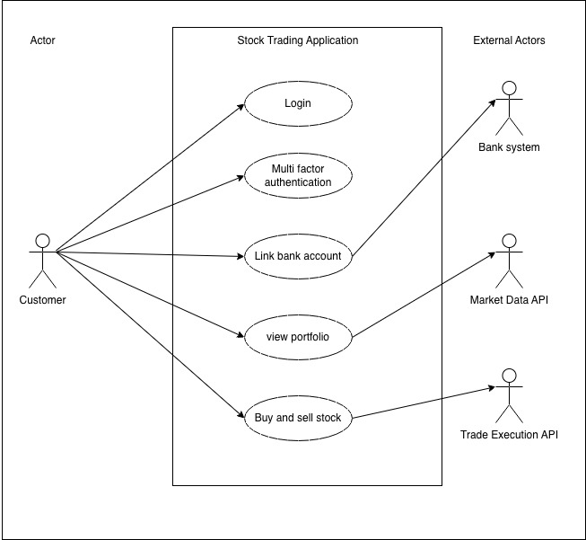

Data Requirements / Modelling

The system will include the following core entities:
- Customer: stores customer identification information, credentials, and KYC status.
- Account: stores linked bank account details and available balance information.
- Portfolio: stores holdings associated with a customer account.
- Trade: stores trade transactions including stock symbol, quantity, price, timestamp, and status.
Relationships:
- A customer may have one or more accounts.
- An account may contain multiple trades and portfolio holdings.
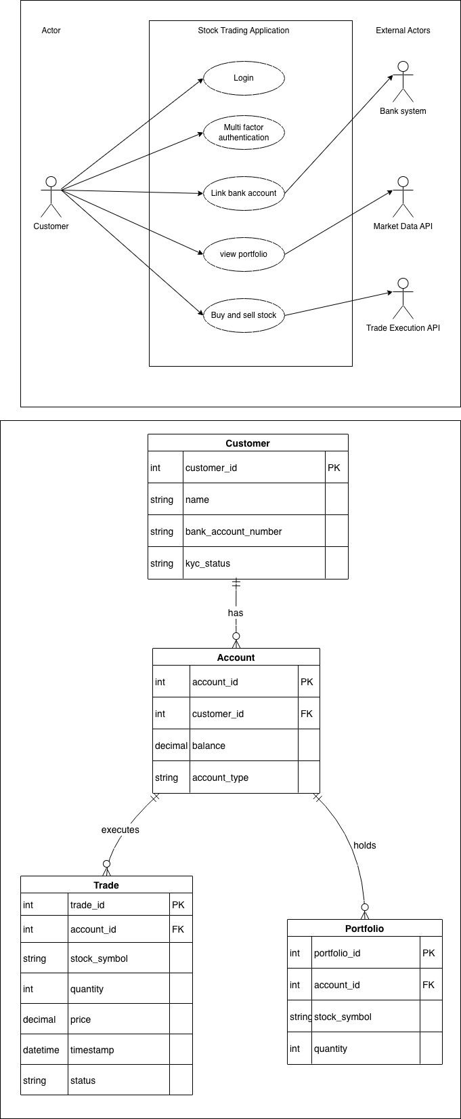

Dependencies

The system depends on integration with a third-party market data provider for real-time stock prices. It also depends on an external trade execution API for processing buy and sell orders. Internal banking APIs are required for account balance retrieval and fund transfers. Cloud hosting infrastructure and database services are required for deployment and scalability.

Assumptions and Constraints

It is assumed that customers already have verified bank accounts and completed KYC requirements before accessing trading functionality. It is assumed that external APIs provide stable, secure, and documented endpoints for integration.
Constraints include regulatory compliance requirements, financial data privacy laws, API rate limits imposed by market data providers, and internal budget and timeline limitations. The system must operate only during official market trading hours for live trade execution.

